PDPL-CO Compliance for Log360
Strengthen data protection and meet PDPL-CO compliance with Log360.
Region: Colombia | Type: Data Privacy | Category: Compliance | Pricing: Free

Overview
The PDPL-CO compliance extension in Log360 helps organizations meet Ley 1581 de 2012 - Data Protection (Colombia), Colombia's statutory personal data protection law regulated by the Superintendencia de Industria y Comercio (SIC) governing collection and processing of personal data by providing centralized log management, real-time security monitoring, and audit logging. The platform supports PDPL-CO requirements for authorization, security measures, sensitive data protection, breach notification, data subject rights, processor oversight, data quality, transfer controls, and SIC compliance.
For Authorization and Consent Principles, Log360 monitors access events to detect unauthorized data collection or processing activities that violate Ley 1581 authorization and consent. To address Sensitive Data Protection, the platform monitors access to sensitive repositories to detect unauthorized usage that violates Colombia's strict sensitive data processing. The extension also supports Data Breach Notification to SIC by providing capabilities that provides real-time threat detection and security monitoring to enable timely breach identification and compliance with SIC breach notification requirements.

Key Features
- Data Breach Notification to SIC: Log360 provides real-time threat detection and security monitoring to enable timely breach identification and compliance with SIC breach notification requirements.
- Data Subject Rights Fulfillment: Log360 maintains audit trails of data access events and account changes to help organizations locate and document personal data for data subject rights requests.
- Data Processor Obligations and Oversight: Log360 monitors third-party access, privilege escalations, and data operations across environments to ensure processor compliance with Ley 1581.
- Data Quality and Purpose Limitation: Log360 tracks database modification events and user access activities to detect out-of-purpose usage and unauthorized alterations to personal records.
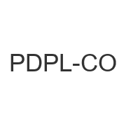

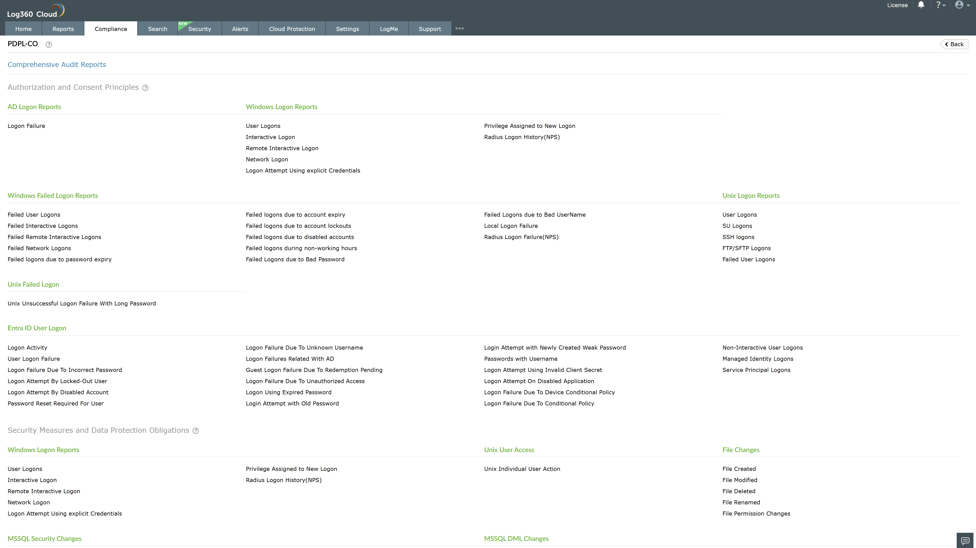
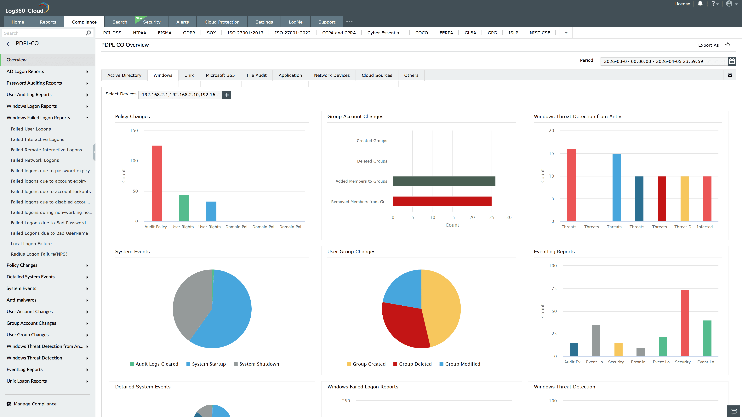
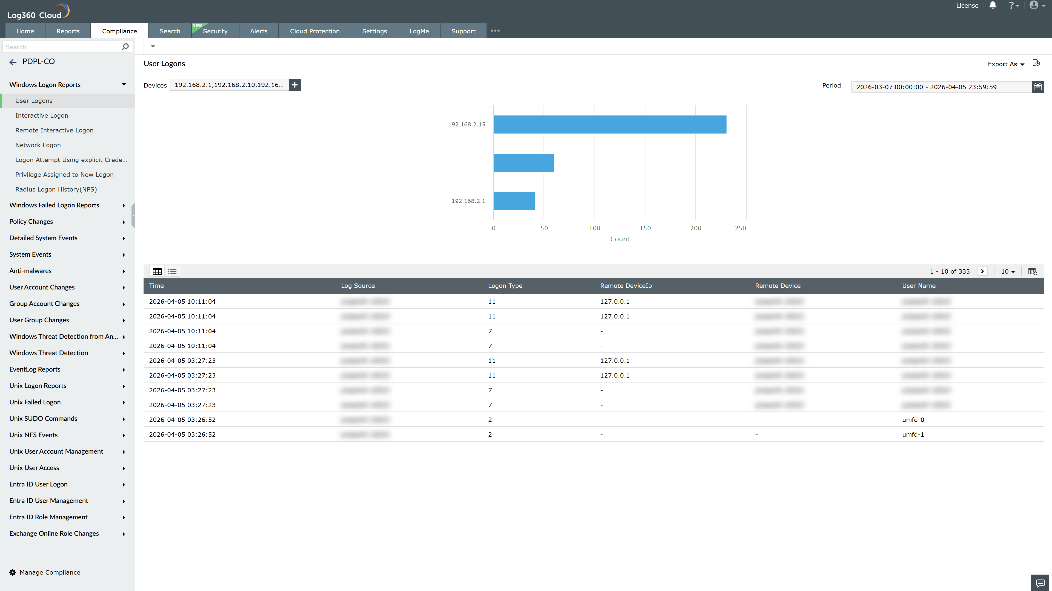
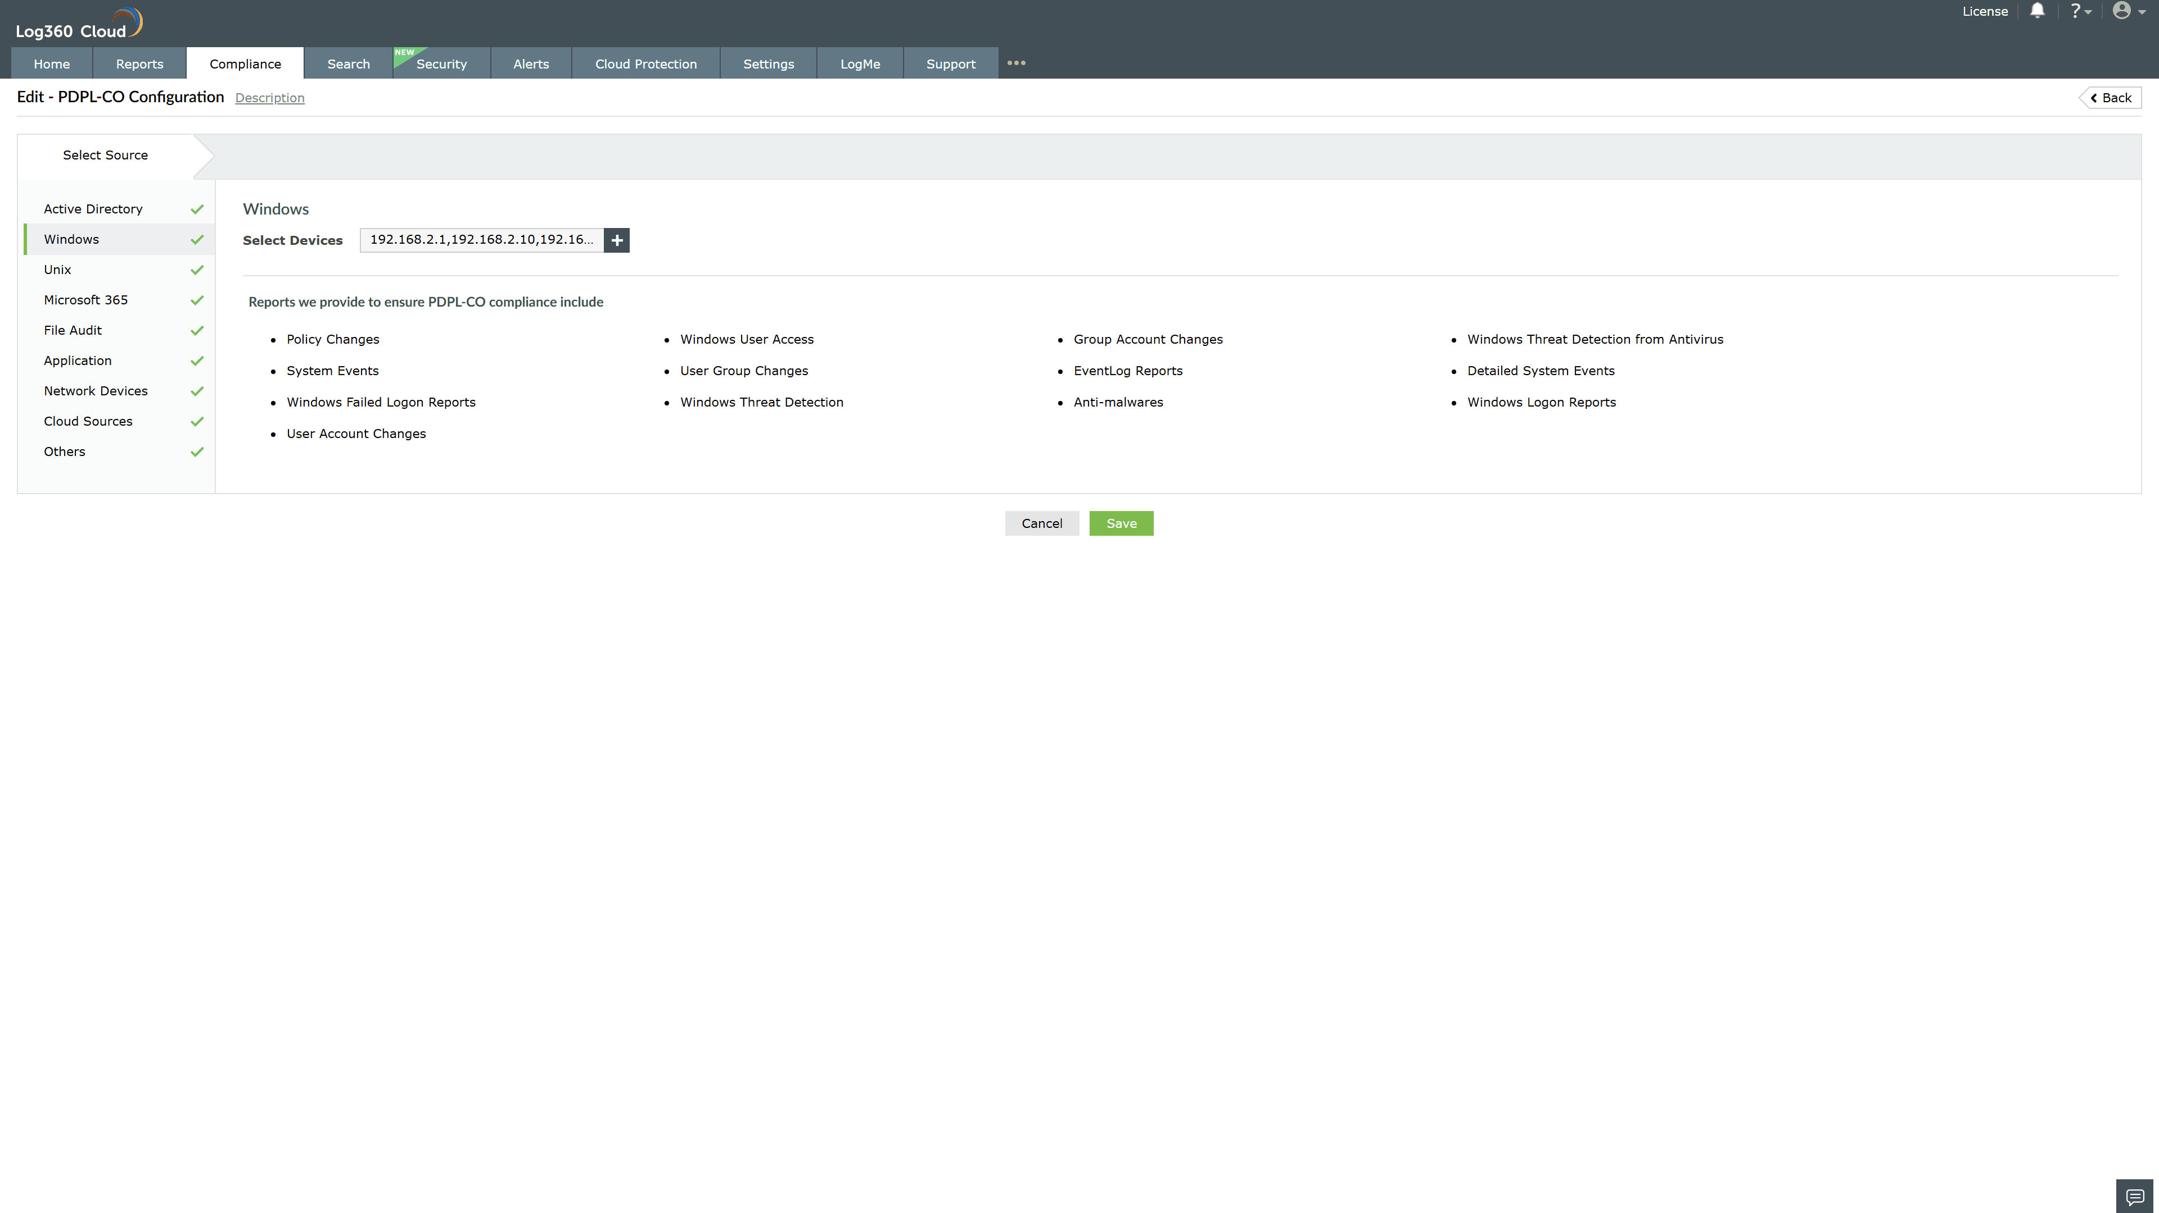
Valid Submission : Yes
Supported Editions : Free, Basic, Standard, Professional, MSSP
Help Document : https://www.manageengine.com/log-management/help/integrations/compliance-extensions.html
Help Video : Not provided
Tags : Log360, Compliance, Privacy monitoring, Data privacy, Regulatory compliance
Supported DCs : US, IN, JP, CA, AU, UK and EU
Privacy Policy:
Terms of Service:
Release Notes:
Predefined reports for the PDPL-CO.

